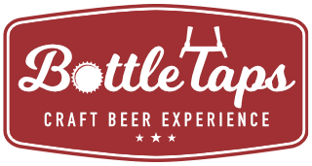

***MENU***

**FOCACCIA TOAST WITH HUMBOLDT FOG, SUGAR BERRY FIGS, AND GUAVA REDUCTION**

PAIRED WITH SHADOW PUPPET TART BREAK

**ARUGULA WITH GOAT CHEESE, PEPITAS, AND MEYER LEMON VINAIGRETTE**

PAIRED WITH SHADOW PUPPET LUSH NECTAR

**CORN CAKES WITH WILD MUSHROOMS AND HICKORY BALSAMIC**

PAIRED WITH SHADOW PUPPET KENTUCKY UNCOMMON COMMON

**CORNISH HEN WITH WILD AND FORBIDDEN RICE, CHANTERELLE AND SHITAKE MUSHROOMS, AND BUTTERNUT SQUASH**

PAIRED WITH SHADOW PUPPET SHATTERED FRENCH SAISON

**HOUSE MADE COCONNUT MACAROONS, CHOCOLATE, AND A COFFEE GLAZE**

PAIRED WITH SHADOW PUPPET KOKONATI

[](https://www.google.com/url?sa=i&rct=j&q=&esrc=s&source=images&cd=&cad=rja&uact=8&ved=2ahUKEwibgefQmdreAhUHGnwKHVUHBq0QjRx6BAgBEAU&url=http://www.shadowpuppetbrewing.com/blog/uncategorized/cool-timelapse-video-shadow-puppet-logo/&psig=AOvVaw1j55w3gsdG5kVf20MxZ8gf&ust=1542501930987663)